Question : 1
Create a 2D NumPy array representing the ratings (out of 5) given by 4 users to 5 different food items on Zomato. Use slicing to extract the ratings given by the second and third users only :
import numpy as np
ratings =np.array([
[4, 5, 3, 4, 5],
[3, 4, 5, 2, 4],
[5, 3, 4, 5, 3],
[2, 4, 3, 4, 5]
])
selected_ratings =ratings[1:3]
print("Original Ratings:")
print(ratings)
print("\nRatings of Second and Third Users:")
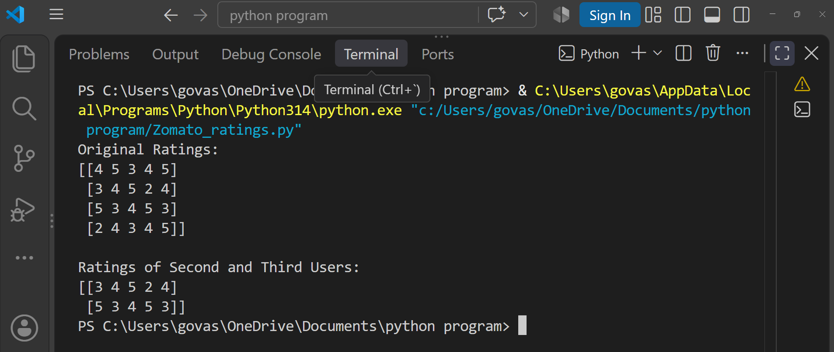
print(selected_ratings)
Question : 2
Given a NumPy array of daily steps tracked for 10 days, use boolean indexing to select only the days where the steps were greater than 8000.<br><br><em><strong>Hint:</strong> Use an array like steps = np.array([7500, 8200, 9000, ...]) and apply a boolean condition : </em>

import numpy as np
steps = np.array([7500,8200,9000,6500,8500,7900,10000,7200,8800,8100])
selected_steps =steps[steps > 8000]
print("Steps greater than 8000:")
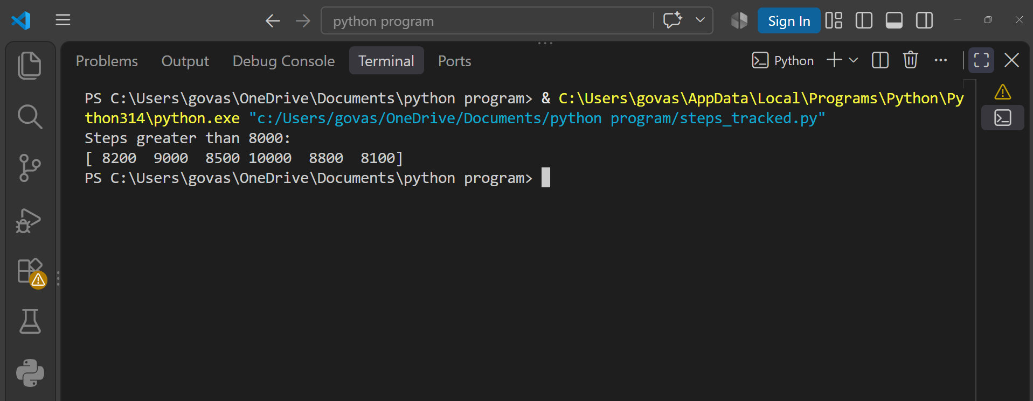
print(selected_steps)

Question : 3
Create a NumPy array of IPL team scores for 8 matches. Use fancy indexing to select the scores from matches 2, 5, and 7, and print them :

import numpy as np
scores =np.array([185,210,156,198,225,172,201,190])
selected_scores = scores[[1,4,6]]

print("Scores from Matches 2, 5 and 7:")
print(selected_scores)
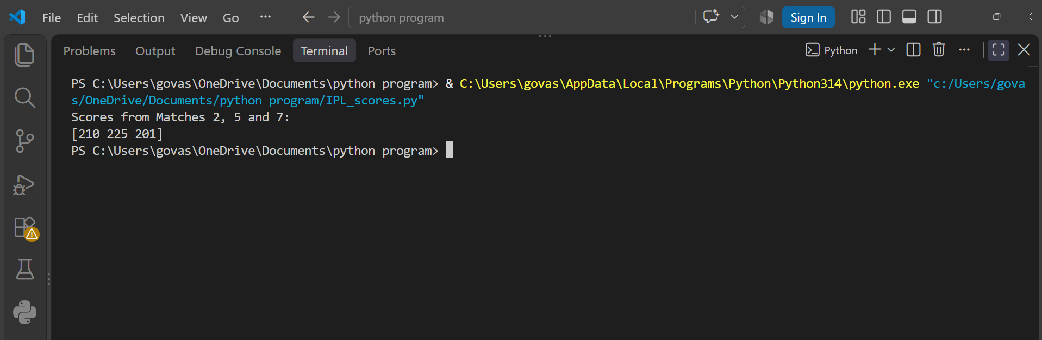

Question : 4
Suppose you have a NumPy array of product prices from Flipkart. Use broadcasting to apply a 10% discount to all prices and print the new array.<br><br><em><strong>Constraint:</strong> Do not use any loops :</em>

import numpy as np
prices = np.array([1000,2500,5000,1200,3000])
discounted_prices =prices * 0.90
print("Original Prices:")
print(prices)
print("\nPrices after 10% discount:")
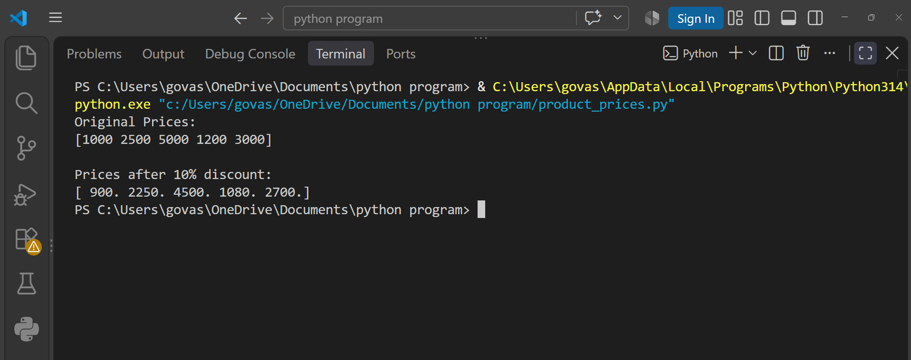
print(discounted_prices)

Question : 5
Given a NumPy array of user ratings (can be negative, zero, or positive) for songs on Spotify, use boolean masking to set all negative ratings to zero, keeping other ratings unchanged :

import numpy as np
ratings =np.array([-2,5,3,-1,0,4,-3,2])
ratings[ratings < 0] = 0
print("Ratings after replacing negative values:")
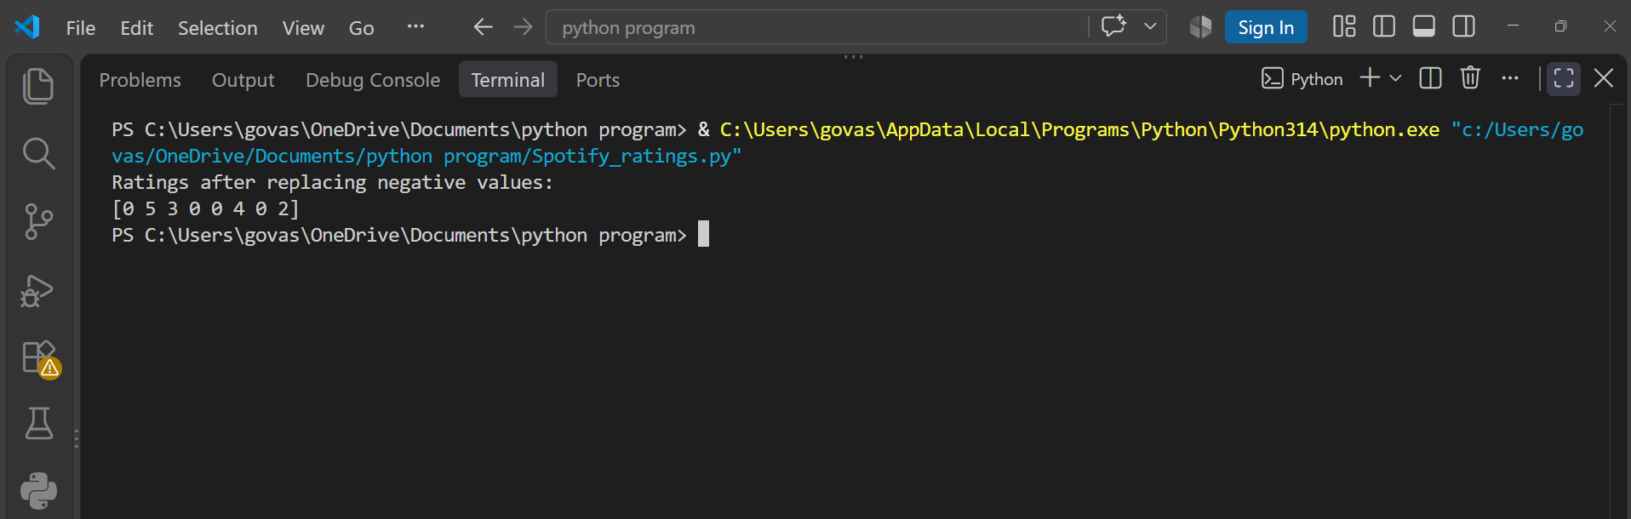
print(ratings)

